An Introduction to
Google Android

Overview and Architecture

What is Google Android?
Google Android, hereafter referred to just as Android, is a software stack for mobile devices that allows software developers to write programs to run and Android-powered devices.
The Android development suite includes an operating system, middleware and some key applications. The Android software development kit (SDK) provides the tools and functionality necessary to begin developing applications on the Android platform using the Java programming language.
Anyone currently familiar with the Java programming language should readily grasp many of the concepts used in Android development, however those who are new to Java but have previous object oriented programming experience should be able to quickly appreciate the concepts that will be used.

Why choose Android ?

There are many reasons why people choose to learn Android development:

- Android is the current ‘big thing’ in mobile application development.
- Android is open source, and as such all aspects of the system environment.
- Android SDK and tools are completely free to download.
- Android development is done in Java, one of the most widely used programming language around today.
- Android development is quick and provides rapid prototyping of applications.
- The rich Android feature set allow impressive looking applications to developed much quicker than on comparative mobile development environments.

Key features of Android SDKs
- Application framework: allows reuse and replacement of components.
- Virtual machine: optimized for mobile devices allowing applications to run quicker .
- Integrated browser based on the open source WebKit technologies/
- Optimized graphics: providing both a set of custom two dimensional liubraries, and three-dimensional libraries based on the industry standard OpenGL ES 1.0 .
- SQLite: SQL database functionality supported to make structured data storage easier.
- Media support: providing audio and video support for many industry standard file formats including MPEG4, MP3, JPG and GIF!
- GSM Telephony : Providing support for making phone calls and text messaging
- Data Communications: Bluetooth, EDGE, 3G, and WiFi (hardware dependent)
- Rich development environment including a fast device emulator, debugging tools and an integrated plug in for the Eclipse IDE.

Android Architecture

As we have already mentioned Android is a stack based system, divided into several key layers.
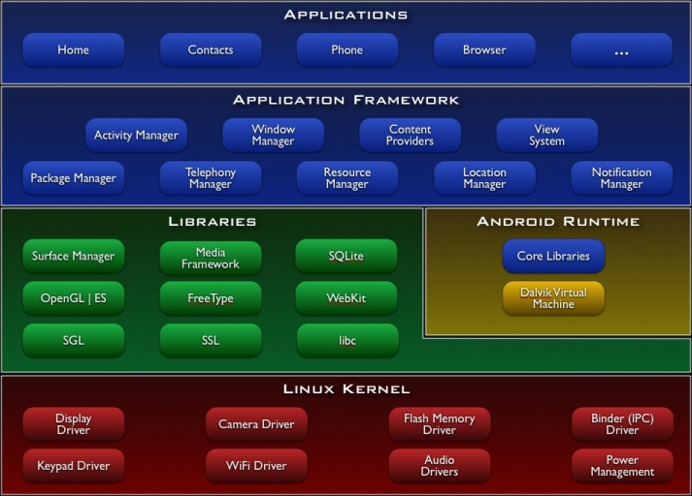
Figure 1 - Android Architecture

Applications
Android will ship with a set of core applications including an email client, SMS program, calendar, maps, browser, contacts, and others. All applications are written using the Java programming language.

Application Framework
Developers have full access to the same framework APIs used by the core applications. The application architecture is designed to simplify the reuse of components; any application can publish its capabilities and any other application may then make use of those capabilities (subject to security constraints enforced by the framework). This same mechanism allows components to be replaced by the user.
Underlying all applications is a set of services and systems, including:
- A rich and extensible set of Views that can be used to build an application, including lists, grids, text boxes, buttons, and even an embeddable web browser
- Content Providers that enable applications to access data from other applications (such as Contacts), or to share their own data
- A Resource Manager, providing access to non-code resources such as localized strings, graphics, and layout files
- A Notification Manager that enables all applications to display custom alerts in the status bar
- An Activity Manager that manages the lifecycle of applications and provides a common navigation stack

Libraries
Android includes a set of libraries used by various components of the Android system. These capabilities are exposed to developers through the Android application framework. Some of the core libraries are listed below:
- System C library - a BSD-derived implementation of the standard C system library (libc), tuned for embedded Linux-based devices
- Media Libraries - based on PacketVideo's OpenCORE; the libraries support playback and recording of many popular audio and video formats, as well as static image files, including MPEG4, H.264, MP3, AAC, AMR, JPG, and PNG
- Surface Manager - manages access to the display subsystem and seamlessly composites 2D and 3D graphic layers from multiple applications
- LibWebCore - a modern web browser engine which powers both the Android browser and an embeddable web view
- SGL - the underlying 2D graphics engine
- 3D libraries - an implementation based on OpenGL ES 1.0 APIs; the libraries use either hardware 3D acceleration (where available) or the included, highly optimized 3D software rasteriser.
- FreeType - bitmap and vector font rendering
- SQLite - a powerful and lightweight relational database engine available to all applications

Android Runtime
Android includes a set of core libraries that provides most of the functionality available in the core libraries of the Java programming language.
Every Android application runs in its own process, with its own instance of the Dalvik virtual machine. Dalvik has been written so that a device can run multiple VMs efficiently. The Dalvik VM executes files in the Dalvik Executable (.dex) format which is optimized for minimal memory footprint. The VM is register-based, and runs classes compiled by a Java language compiler that have been transformed into the .dex format by the included "dx" tool.
The Dalvik VM relies on the Linux kernel for underlying functionality such as threading and low-level memory management.

Linux Kernel
The Android kernel is currently based on Linux v2.6 and as relies on this for core system services such as security, memory management, process management, network stack, and driver model. The kernel also acts as an abstraction layer between the hardware and the rest of the software stack.

